Press release

New album by Nilla Nielsen ”Higher Ground”
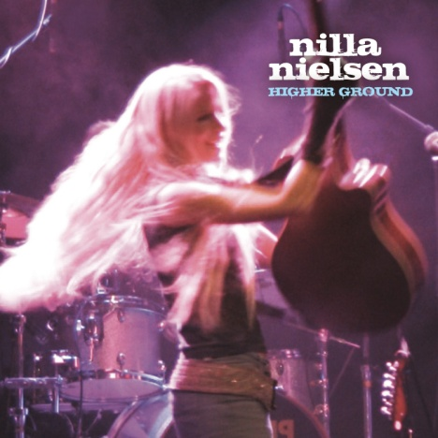
Higher Ground is the title of the fourth full-length album from the productive composer / indie artist and producer Nilla Nielsen. She lets us get very close to her in a brilliant collection of songs that she has written, produced and in which she plays most of the instruments herself. The sound is personal, her voice warm and, if possible, more sensitive and sincere than ever. In the disclosure lyrics about complicated relationships she has her own expression and a language that affects. The album has an exciting breadth of naked acoustic songs as well as rebellious pop/rock.
In the allegory "The UFO Song (The Guinea Pig Song) " and the soulful "Hymn For Orangutan (Lullaby For the Wounded)" Nilla expresses her strong commitment to a better world and her desire to give victims a voice.
In the cocky "Then You Said I Made You Feel Unfaithful" we hear a new sound from Nilla as well as in the intense single "Salt" with an evocative melancholy in the spirit of the Swedish band ”Kent”.
You can hear influences even from the likes of Tracy Chapman and Peter Gabriel while Nilla has her very own style, a rock fairy dancing was as natural light in ethereal dreams on the rock scene.
Previous albums:
”Redemption Sky”, 2004
”Shellshocked” 2008
”Shadows” 2010

More information:
Nillas - http://www.nillanielsen.com
Nilla Nielsen, 073-686 28 42, info@nillanielsen.com
Peter Hemgard, 0708-93 19 86, promotion@nillanielsen.com

